|  |  |  |
| --- | --- | --- |
|  | **JSPM’s**  **RAJARSHI SHAHU COLLEGE OF ENGINEERING**  **TATHAWADE, PUNE-33**  **(An Autonomous Institute Affiliated to SavitribaiPhule Pune University,Pune)** |  |

1. **Statement of Clear Goal, Use of appropriate methods, Significance of results, Effective presentation**

**Name of the Course:** Ethical Hacking

**Name of the Faculty:** Prof. Taniya Bhattacharjee

**Name of the Innovative Method used:** YouTube Video

**Name of the topic:** Introduction to Ethical hacking

**Statement of Clear Goal**: To help students understand topics better by using YouTube videos in teaching, so they can learn anytime, review difficult concepts, and enjoy learning through visual content.

**Significance of result:** After watching the video, students were able to understand the topic more clearly, remember key points better, and showed improved participation and performance in related activities or assessments.

**Effective Presentation (Screenshot):**

**Peer Review and Critique (Feedback):**

Video link: <https://www.youtube.com/watch?v=LwlXQAN631I>

1. **Availability of work related to Innovation by Faculty in Teaching and Learning is on Institute website.**

[**https://www.jspmrscoe.edu.in/information-technology/innovation-practices**](https://www.jspmrscoe.edu.in/information-technology/innovation-practices)

1. **Availability of work for peer review and critique.**

**Work is available for peer review and critique on github.**

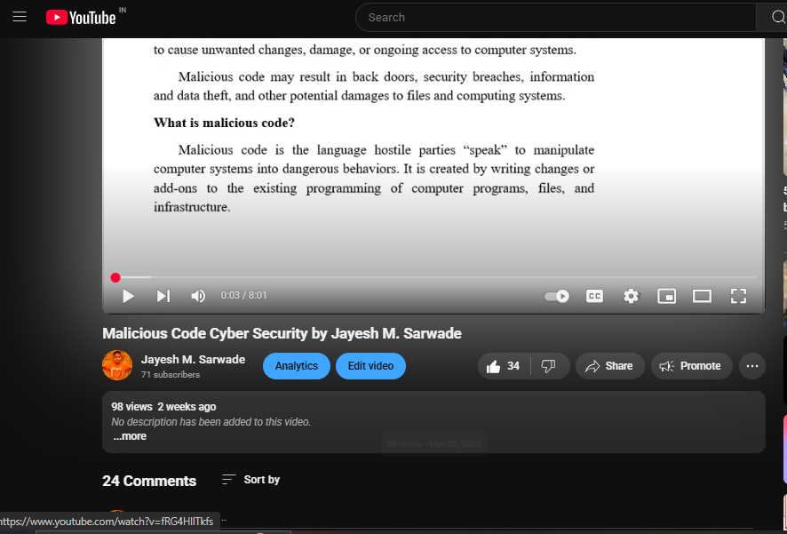

**D: Reproducibility and Reusability by other scholars for further development**

* **Views**, **likes**, **comments**, and **shares: P**eople are engaging with and potentially applying the content.
* Students are forwarding video to other for watching
* Students are giving Comments
* Viewers are thinking critically and considering extensions
* This video is linked to GitHub repositories. Viewers can **download and can** modify it.

The link of github repository is as follows:

<https://github.com/users/jayeshsarwade/projects/1/views/1?layout_template=table>

|  |  |  |  |
| --- | --- | --- | --- |
| **Sr.No** | **Innovation Used by** | **Details of User** | **Purpose of**  **Reproducibility and Reusability** |
| **1.** | **YouTube Video** | **Dr. Jayesh M. Sarwade** | To allow viewers to **repeat the process or concept** shown in the video and obtain the same results.  To. Encourage knowledge sharing and collaboration. |
|  |  |  |  |

**Course Co-ordinator Module Co-ordinator HOD**

Dr. Jayesh M. Sarwade Dr. S.M. Chaware Dr. Nihar M. Ranjan